**RUNTIME TEXTBOX in VB.NET**

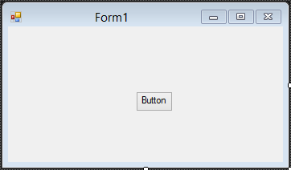

**SYNTAX:**

Public Class Form1

Dim i As Integer = 1

Private Sub Button1_Click(sender As Object, e As EventArgs) Handles Button1.Click

AddNewTextBox()

End Sub

Public Function AddNewTextBox() As System.Windows.Forms.TextBox

Dim txt As New System.Windows.Forms.TextBox()

Me.Controls.Add(txt)

txt.Top = i * 25

txt.Left = 50

txt.Text = "TextBox" & Me.i.ToString

i = i + 1

Return txt

End Function

End Class